ITN 267 Assignment 3
Answer the following to the best of your ability in complete sentences with proper spelling and grammar. Be sure to elaborate on your answers and provide support for each of your statements. Format your answers in blue font.
- Case Scenario: CreditSolutions v FTC
Read the case scenario at https://www.ftc.gov/news-events/press-releases/2006/02/cardsystems-solutions-settles-ftc-charges.
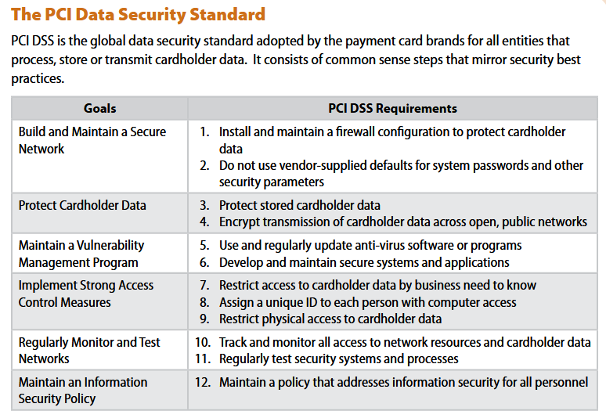
Based upon PCI DSS Security Standards, summarized above, answer the following questions:
- Who do you think is negligent in this case and why?
- Explain which requirements weren’t met and how those violate the Federal Trade Commission Act.
- Recommend two or three mitigation remedies to prevent the same thing from happening at another organization.
- What are the possible consequences associated with the data loss?
- Who do you think is ultimately responsible for the CardSystems Solutions’ lack of PCI DSS compliance?

- Security and Privacy of Information Belonging to Children and in Educational Records

- List some of the challenges with protecting children on the Internet.
- Identify the purpose of COPA and describe its main requirements.
- Identify the purpose of CIPA and describe its main requirements.
- Identify the purpose of FERPA and describe its main requirements.
- If the government restrict’s a child’s access to objectionable online materials is that a violation of their first amendment rights? Does this also restrict free speech? Explain your answers.

